Experiment 1: Creating and Using a User-Defined Package
Aim:
To create a user-defined package and access its class from another Java program.
Tasks:
- Create a package named mypackage.
- Create a class Student inside the package.
- Define student details and a method to display them.
- Create another class outside the package.
- Import and use the Student class.
package mypackage;
class Student {
private int id;
private String name;
public Student(int id, String name) {
this.id = id;
this.name = name;
}
public void display() {
System.out.println("Student ID: " + id);
System.out.println("Student Name: " + name);
}
}
public class Exp1_PackageDemo {
public static void main(String[] args) {
Student student = new Student(145, "Martin");
student.display();
}
}
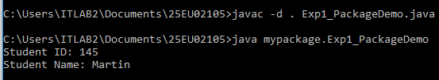

Experiment 2: Importing Packages
Aim:
To demonstrate different ways of importing and accessing classes from a package.
Tasks:
- Create a package college.
- Create classes Student and Faculty.
- Import a specific class from the package.
- Demonstrate wildcard import using college.*.
- Access the classes from another program.
package college;
class Student {
public void showStudent() {
System.out.println("Accessing Student class from college package.");
}
}
class Faculty {
public void showFaculty() {
System.out.println("Accessing Faculty class from college package.");
}
}
public class Exp2_ImportDemo {
public static void main(String[] args) {
Student student = new Student();
Faculty faculty = new Faculty();
student.showStudent();
faculty.showFaculty();
}
}
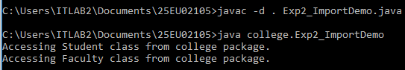

Experiment 3: Packages and Member Access
Aim:
To demonstrate the accessibility of class members across packages using access modifiers.
Tasks:
Create a class containing:
- public member
- private member
- protected member
- default member
Access these members from:
- The same class
- Another class in the same package
- A class in a different package
package pack1;
class AccessBase {
public int publicVar = 10;
private int privateVar = 20;
protected int protectedVar = 30;
int defaultVar = 40;
public void testSameClass() {
System.out.println("--- 1. Same Class Access ---");
System.out.println("Public: " + publicVar);
System.out.println("Private: " + privateVar);
System.out.println("Protected: " + protectedVar);
System.out.println("Default: " + defaultVar);
}
}
class SamePackageClass {
public void testSamePackage() {
AccessBase obj = new AccessBase();
System.out.println("\n--- 2. Same Package Class Access ---");
System.out.println("Public: " + obj.publicVar);
System.out.println("Protected: " + obj.protectedVar);
System.out.println("Default: " + obj.defaultVar);
}
}
class SubclassInPackage extends AccessBase {
public void testSubclass() {
System.out.println("\n--- 3. Subclass Access Rules ---");
System.out.println("Public: " + publicVar);
System.out.println("Protected: " + protectedVar);
System.out.println("Default: " + defaultVar);
}
}
public class Exp3_AccessDemo {
public static void main(String[] args) {
AccessBase base = new AccessBase();
base.testSameClass();
SamePackageClass samePkg = new SamePackageClass();
samePkg.testSamePackage();
SubclassInPackage sub = new SubclassInPackage();
sub.testSubclass();
}
}
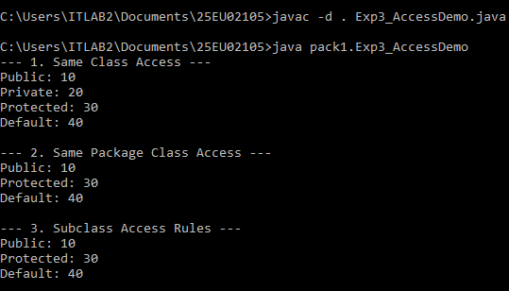

Experiment 4: Demonstrate CLASSPATH
Aim:
To demonstrate how Java uses the CLASSPATH to locate user-defined packages and classes.
Tasks:
- Create a package utilities.
- Create a class Calculator.
- Compile the package.
- Set the CLASSPATH.
- Write another Java program that uses the Calculator class.
- Compile and execute the program using the configured CLASSPATH.

package utilities;

class Calculator {

public int add(int a, int b) {

return a + b;

}

}

public class Exp4_ClasspathDemo {

public static void main(String[] args) {

Calculator calc = new Calculator();

int result = calc.add(15, 25);

System.out.println("Calculation Result via Package: " + result);

}

}
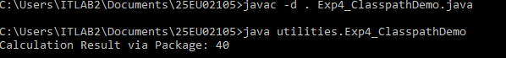

Experiment 5: Package Containing Multiple Classes
Aim:
To create and use a package containing multiple classes.
Tasks:
Create a package named bank containing:
- Account
- Customer
- Transaction
Create a main class outside the package and access all three classes.
package bank;
class Account {
private String accountNumber;
private double balance;
public Account(String accountNumber, double balance) {
this.accountNumber = accountNumber;

this.balance = balance;

}

public void displayAccountInfo() {

System.out.println("Account Number: " + accountNumber + " | Balance: $" + balance);

}

}

class Customer {

private String name;

public Customer(String name) {

this.name = name;

}

public void displayCustomerInfo() {

System.out.println("Customer Name: " + name);

}

}

class Transaction {

private String transactionId;

private double amount;

public Transaction(String transactionId, double amount) {

this.transactionId = transactionId;

this.amount = amount;

}

public void displayTransactionInfo() {

System.out.println("Transaction ID: " + transactionId + " | Amount: $" + amount);

}

}

public class Exp5_BankDemo {

public static void main(String[] args) {

Customer customer = new Customer("John Doe");

Account account = new Account("ACC12345", 5000.00);

Transaction transaction = new Transaction("TXN98765", 1500.00);

customer.displayCustomerInfo();

account.displayAccountInfo();

transaction.displayTransactionInfo();

}

}
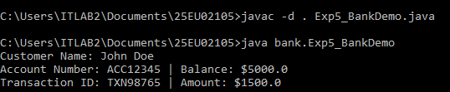

INTERFACES

Experiment 6: Defining and Implementing an Interface
Aim:
To create an interface and implement its methods in a class.
Problem Statement:
Create an interface Shape containing a method area(). Implement the interface using Circle and Rectangle classes.
interface Shape {
void area();
}
class Circle implements Shape {
private double radius;
public Circle(double radius) {
this.radius = radius;
}
@Override
public void area() {
System.out.println("Area of Circle: " + (Math.PI * radius * radius));
}
}
class Rectangle implements Shape {
private double length;
private double width;
public Rectangle(double length, double width) {
this.length = length;
this.width = width;
}
@Override
public void area() {
System.out.println("Area of Rectangle: " + (length * width));
}
}
public class Exp6_ShapeInterface {
public static void main(String[] args) {
Shape circle = new Circle(5.0);
Shape rectangle = new Rectangle(4.0, 6.0);
circle.area();
rectangle.area();
}
}
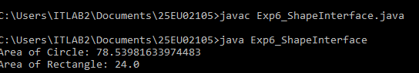

Experiment 7: Implementing Multiple Interfaces
Aim:
To demonstrate how a class can implement multiple interfaces.
Problem Statement:
Create two interfaces:

Printable
|
+-- print()

Showable
|
+-- show()

Create a class Demo that implements both interfaces.
Expected Output:

Printing...
Showing...

interface Printable {
void print();
}
interface Showable {
void show();
}
class Demo implements Printable, Showable {
@Override
public void print() {
System.out.println("Printing...");
}
@Override
public void show() {
System.out.println("Showing...");
}
}
public class Exp7_MultipleInterfaces {
public static void main(String[] args) {
Demo obj = new Demo();
obj.print();
obj.show();
}
}
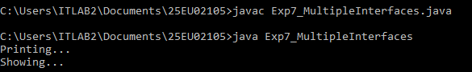

Experiment 8: Interface-Based Polymorphism
Aim:
To demonstrate polymorphism using an interface reference.
Problem Statement:
Create an interface Vehicle with a method start(). Implement it using Car and Bike.
Use:

Vehicle v;

and assign objects of both Car and Bike to the reference.
interface Vehicle {
void start();
}
class Car implements Vehicle {
@Override
public void start() {
System.out.println("Car starts with key ignition.");
}
}
class Bike implements Vehicle {
@Override
public void start() {
System.out.println("Bike starts with self-start button.");
}
}
public class Exp8_InterfacePolymorphism {
public static void main(String[] args) {
Vehicle v;
v = new Car();
v.start();
v = new Bike();
v.start();
}
}
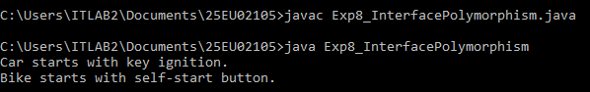

Experiment 9: Variables in Interfaces
Aim:
To demonstrate variables declared inside an interface.
Problem Statement:
Create an interface Constants containing constants such as:

int MAX_MARKS = 100;
double PI = 3.14159;

Access these variables from a class implementing the interface.
Tasks:
- Declare variables in an interface.
- Access them using the interface name.
- Demonstrate that interface variables are constants.
interface Constants {
int MAX_MARKS = 100;
double PI = 3.14159;
}

class StudentResult implements Constants {
public void display() {
System.out.println("Max Marks inside class: " + MAX_MARKS);
System.out.println("PI Value inside class: " + PI);
}
}
public class Exp9_InterfaceVariables {
public static void main(String[] args) {
System.out.println("Accessing via Interface Name:");
System.out.println("MAX_MARKS: " + Constants.MAX_MARKS);
System.out.println("PI: " + Constants.PI);
System.out.println("\nAccessing inside implementing class:");
StudentResult result = new StudentResult();
result.display();
}
}
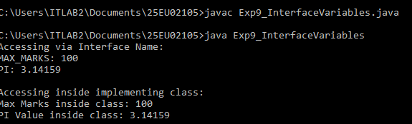

Experiment 10: Nested Interfaces
Aim:
To demonstrate the concept of nested interfaces.
Problem Statement:
Create an outer class University containing a nested interface Department.
Implement the nested interface in another class and demonstrate its functionality.
class University {
interface Department {
void displayDepartmentInfo();
}
}
class ComputerScience implements University.Department {
@Override
public void displayDepartmentInfo() {
System.out.println("Department: Computer Science and Engineering");
}
}
public class Exp10_NestedInterface {
public static void main(String[] args) {
University.Department dept = new ComputerScience();
dept.displayDepartmentInfo();
}
}
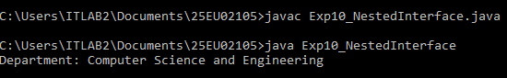

Experiment 11: Interface Inheritance
Aim:
To demonstrate inheritance between interfaces.
Problem Statement:
Create:

interface Animal
|
| extends
↓
interface Dog
|
| implemented by
↓
Labrador

Animal should contain eat(), while Dog should contain bark().
Implement both methods in Labrador.
interface Animal {
void eat();
}
interface Dog extends Animal {
void bark();
}
class Labrador implements Dog {
@Override
public void eat() {
System.out.println("Labrador is eating.");
}
@Override
public void bark() {
System.out.println("Labrador is barking.");
}
}
public class Exp11_InterfaceInheritance {
public static void main(String[] args) {
Labrador lab = new Labrador();
lab.eat();
lab.bark();
}
}
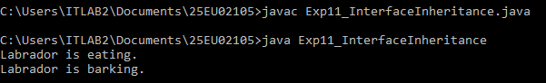

Experiment 12: Real-World Application Using Interfaces
Aim:
To develop a Java application using interfaces.
Problem Statement:
Develop a Payment Processing System using an interface Payment.
The interface should contain:

void pay(double amount);

Implement it using:
- CreditCardPayment
- UPIPayment
- NetBankingPayment
The main program should allow the user to select a payment method and process the payment.
Concepts Covered:
- Interfaces
- Implementing interfaces
- Polymorphism
- Abstraction
- Multiple implementations
- Real-world application of interfaces
import java.util.Scanner;

interface Payment {
void pay(double amount);
}

class CreditCardPayment implements Payment {
@Override
public void pay(double amount) {
System.out.println("Successfully processed Credit Card Payment of $" + amount);
}
}

class UPIPayment implements Payment {
@Override
public void pay(double amount) {
System.out.println("Successfully processed UPI Payment of $" + amount);
}
}

class NetBankingPayment implements Payment {
@Override
public void pay(double amount) {
System.out.println("Successfully processed Net Banking Payment of $" + amount);
}
}

public class Exp12_PaymentSystem {
public static void main(String[] args) {
Scanner scanner = new Scanner(System.in);
Payment payment = null;

System.out.println("--- Payment Gateway ---");
System.out.println("1. Credit Card");
System.out.println("2. UPI");
System.out.println("3. Net Banking");
System.out.print("Select payment method (1-3): ");
int choice = scanner.nextInt();

System.out.print("Enter amount to pay: ");
double amount = scanner.nextDouble();

switch (choice) {
case 1:
payment = new CreditCardPayment();
break;
case 2:
payment = new UPIPayment();
break;
case 3:
payment = new NetBankingPayment();
break;
default:
System.out.println("Invalid Payment Method Selected!");
scanner.close();
return;
}

System.out.println();
payment.pay(amount);
scanner.close();
}
}


